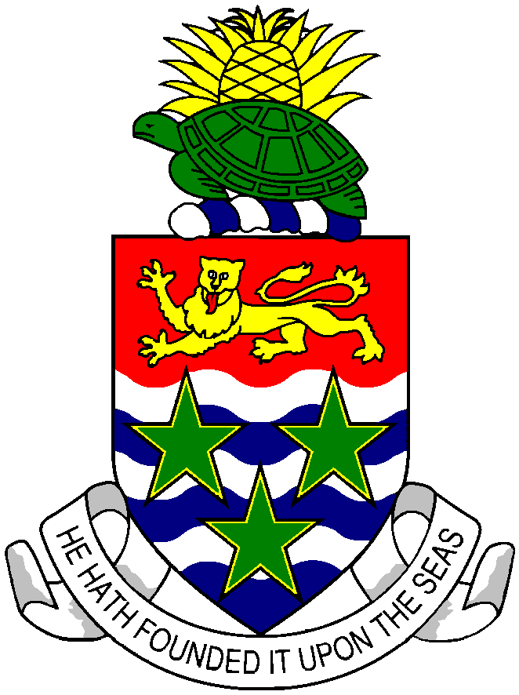
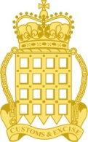
CUSTOMS DEPARTMENT

Delivery Address: Mailing Address:
P.O. Box 898
Grand Cayman KY1-1103
CAYMAN ISLANDS

Customs Headquarters
42 Owen Roberts Drive
Grand Cayman
CAYMAN ISLANDS
Telephone (345) 949-4579 / Facsimile (345) 945-1573

6th December 2017

PRESS RELEASE

Another Cocaine Arrest at the Airport

The Collector of Customs Charles Clifford has announced the arrest of a 30 year old Caymanian male from the district of Bodden Town for Possession of almost two (2) pounds of Cocaine at the Owen Roberts International Airport. The male passenger was arrested following his arrival on a domestic flight from Cayman Brac on the morning on 5th December 2017.
Mr. Clifford said that this arrest was the result of a joint Customs and Royal Cayman Police Service operation. He said, “We have once again seen the advantage of our strategy to significantly increase joint operations with our partner law enforcement agencies such as the RCIPS and Immigration Department. On this occasion I wish to thank the RCIPS for their invaluable assistance with this operation and our dedicated Customs Officers for their professionalism, determination and focus.”
Assistant Collector of Customs Tina Campbell, who has responsibility for the Customs Narcotic Enforcement Team, said, “This is another fine result from the progress which is achieved when we work together. We expect more results such as this as we continue to strengthen our alliance to enhance border security efforts.”
Commenting on behalf of the RCIPS, Commissioner of Police, Derek Byrne, said, “Results like this only serve to strengthen the RCIPS’ commitment to working closely with our partner law enforcement agencies in order to increase the safety of these Islands. We are extremely proud of the role our officers played in ensuring the success of this operation.”
The investigation associated with this recent arrest is ongoing.

